**Brooklyn torah gazette**

**For parshas Lech Lecha 5783**

Volume 7, Issue 6 (Whole Number 313) 4 Cheshvon 5783/ October 29, 2022

**Printed L’illuy nishmas Nechama bas R’ Noach, a”h**

For a free subscription, please forward your request to [***keren18@juno.com***](mailto:keren18@juno.com)

Past stories can be found on the website **ShabbosStories.com**

**The Meeting of Kaiser Franz Josef and the “Five” Angels**

**By Yehuda Z. Klitnick**

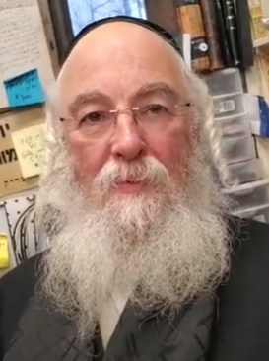

**Reb Yehuda Klitnick**

The Reform movement was formed in the year 1810. There was great friction between the Reform and the Orthodox as both sects davened in the same Shul and basically shared the same community.

In Germany, it was Reb Shamshon Refoel Hirsch z’’tzal who was the staunch opposer to them. In Hungary, it was the Gaon the Chasam Sofer - Reb Moshe Sofer z’’tzal - who was one of the strongest of the opposers to the reform movement and he decided that because of the changes brought about by the Reform movement, Orthodox Jews must create separate communities for themselves in Hungary, in order not to assimilate with the Reform Jews.

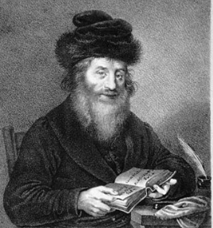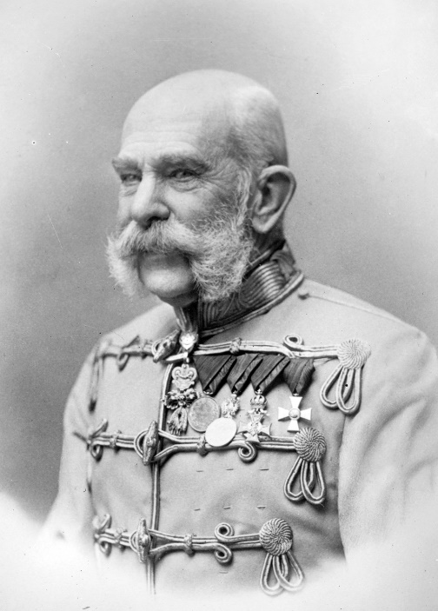

**The Chasam Sofer and Kaiser (Emperor) Franz Josef of Austria-Hunarian Empire**

This was known in Yiddish as “the Upteilung”.The Reform movement had very close ties with the Government, and in order to achieve “the Upteilung” it was now necessary to receive the royal approval for this. Therefore, the Rabbonim met and decided upon to choose five of the most famous Rabbonim and Tzaddikim of Hungary to send them as a a delegation to the Kaiser Franz Josef, who was known to be a rational person.

**Distinguished Members of the Rabbinical Delegation**

Among the delegation were Reb Yehuda Assad, the famous author of Teshuvas Yehuda Ya’aleh and Chidushei Maharia on theTorah, Reb Akiva Yosef Shlezinger the Lev Haivri and many more seforim, and his father-in-law, Reb Hillel Lichtenstein of Kolomyia author of Eis Laasos and Maskil El Dal and many more.

Reb Akiva Yosef, in his sefer Bris Olam, relates that the night before their meeting with the Kaiser, he was lodging with his father-in-law Reb Hillel. In the middle of the night, he was awakened by Reb Hillel, who asked him,“Are you asleep?”

Reb Akiva Yosef replied that he was awake.

“Do you see anything?” asked Reb Hillel of his son-in-law.

“No,” came the answer.

**Repeated Asked the Same Question**

After a while Reb Hillel asked again, “Do you see anything?”

Again, Reb Akiva Yosef replied, “No, I don’t see anything.”

After that, Reb Hillel woke him once again with the same question, and once again Reb Akiva Yosef gave the same reply.

Reb Hillel politely explained, “I just saw my Rebbe the Chasam Sofer in a dream and he told me, “You have davened well. Go to the Kaiser, and your mission will be successful.”

“I told the Chasam Sofer that the guards would never allow us an audience with the king! The Rebbe answered Hashem will have you seen as angels and the guards will not notice you!

The next morning the entire delegation went to the Kaiser’s palace. They found all the gates open, with no guard or anyone else to stop them or ask them questions. So, they walked right in to the palace grounds.

**The Kaiser was Only Wearing a Simple House Robe**

The Kaiser was taking his morning stroll, was not notified of the sudden guests, was only wearing a simple house robe. When the Kaiser saw them, he exclaimed, “Five angels!”

The members of the delegation had removed their hats, as is customary when standing before a king. Reb Yehuda Assad approached the king and said, “If His Majesty will allow it, I would like to put on my hat so that I can recite the blessing we say when we see a king.”

The Kaiser graciously answered, “Of course, but please wait a minute. I too would like to cover my head. ”

**The “Five” Angels Bestow the Blessing for a Monarch**

Then the Kaiser went into the palace and put on his crown, and afterwards Reb Assad and the others recited the Bracha as is the Halacha in Shulchan Aruch Orach Chaim 224:8: “Blessed are You, L-rd our G-d, Who has imparted of His honor to flesh and blood.”

Afterwards the Kaiser asked them what was the purpose of their visit. The Rabbonim had originally chosen one of the Rabbanim, a talmid of the Chasam Sofer, since he was an eloquent orator and fluent in the language that he would present their request; but now he found himself unable to open his mouth.

The Kaiser realized that the young man was overcome with awe before him and therefore could not speak. He said,“Instead of speaking, just put your request in writing, and whatever you wish, I will grant.”

They immediately wrote their request, that the Kaiser give them the necessary recognition so that they could function as a separate community with due legal authority. The Kaiser took their request and, without even reading its contents, folded it. This was the royal sign that the request had been granted.

**The Kaiser Asked for a Special Blessing**

Afterwards, the Kaiser was about to take leave of his five guests, but first he asked for a blessing from Reb Yehuda Assad, who appeared to him as handsome as an angel. Reb Assad blessed him with a long life and a long and successful reign. It is known that the blessing was fulfilled, for the Kaiser was still king at the age of eighty-four.

When they left the Kaiser, they met the palace director, who was astonished to discover that five strangers had entered the palace without any hindrance. He asked them, “How did you enter without permission?”

They answered, “No, we are not entering. We are leaving.” Upon hearing this he was so astonished that he simply walked away. This miracle was performed from the Holy Chasam Sofer in order to allow the separation of the communities and the continuation of the Orthodox Jews in Hungary and eventually throughout the world. The Rabbanim were not swayed by the masses. They went with the Emes, and Leshaim Sh’mayim. (Yehuda Z. Klitnick at pardesyehuda1@ gmail.com)

*Reprinted from the Lech Lecha 5783 email of R’ Yedidye Hirtenfeld’s whY I Matter parsha sheet of the Young Israel of Midwood in Brooklyn, NY.*

******************************************************************

“But also, the nation that they shall serve, dan Anochi / I [shall] judge . . .” (15:14)

R’ David Hanaggid z”l (1224-1300; grandson of Rambam z”l) writes: According to the rules of grammar, G-d should have said, “adun,” rather than “dan.” However, “dan” alludes to the Ten Plagues–the dalet alludes to the first plague, “dam” / “blood,” while the nun alludes to the last plague, which the Torah (Shmot 11:1) refers to as a “nega” (literally, “plague”). (Midrash Rabbi David Hanaggid al Haggadah Shel Pesach)

*Reprinted from the Lech Lecha 5783 email of R’ Yedidye Hirtenfeld’s whY I Matter parsha sheet of the Young Israel of Midwood in Brooklyn, NY.*

**Rabbi Berel Wein on**

**Parshas Lech Lecha**

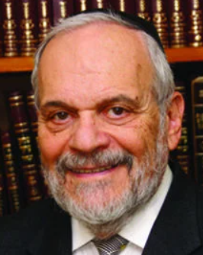

There is much comment and many different interpretations regarding the first two words of the second verse of this week’s Torah reading. The second word “lecha” – “for you” seems to be somewhat redundant in the construction of the sentence. Rashi therefore interprets it to mean “for your benefit and good.” The L-rd instructs Abraham to leave his homeland and family located in Mesopotamia, in order to achieve the greatness that is inherent within him, as the forbearer of nations and the founder of the Jewish people.

There is an alternative interpretation of the use of this second word “lecha” in the verse that has always fascinated me. Travel can be a very broadening and entertaining experience. The travel industry the world over is bourgeoning as people crave to visit unseen shores and exotic locations. So why would the travel of Abraham and Sarah from Mesopotamia to the land of Canaan be considered by Jewish tradition to have been such a challenging test of Abraham’s faith on the A-mighty?

He simply was embarking on a travel experience and was one of many such travelers in his time and world. The answer lies in the fact that the word “lecha” implies permanence.  Abraham, you are never going to return home to Mesopotamia again. You are not a visitor, a tourist, a traveler, but you are now a refugee, an alien, and a non-citizen.

And such a status in life is truly challenging and potentially dangerous. So, unlike the interpretation of Rashi, the word “lecha” has a certain ominous characteristic to it.  Abraham and Sarah were to be truly challenged by this travel experience. They were not going on vacation.

Abraham’s descendants, the Jewish people, have shared this test and challenge with him over our long history. We always were insecure and homeless during the long night of our exile and dispersal. Even countries where Jews resided for centuries, such as Spain, Germany, Poland, etc., eventually no longer would accommodate our presence. We were always a positive part of any national society we found ourselves in but at the same time we were always the odd man out.

But somehow we were able to survive this enormous test and challenge because we always believed and knew that eventually we were going to go home. We prayed for it to happen and we struggled against all odds and enemies to make it happen. And in our time it has happened.

This belief of the return to Zion and Jerusalem sustained us in our darkest hours. It transferred us in our minds, though not in the minds of others, from the status of tolerated but unwanted aliens into mere visitors and sojourners who have a legitimate and permanent home elsewhere. This is the feeling I have every time I present my Israeli passport for inspection when I travel to a foreign destination. I am no longer a pariah, a refugee but merely a visitor, a tourist, perhaps even an honored guest. The children of Abraham have returned home.

Shabbat shalom

*Reprinted from this week’s website of rabbiwein.com*

*\***Rav Avigdor Miller on**

**Making Friends with Resha’im**



**QUESTION:** **How should I deal with people who are nasty or unpleasant?  Should I be nice to them?**

**ANSWER:** And the answer to that is a resounding yes. Look, if it’s a person with whom there is no use talking because the more you talk the more insolent he becomes, then make it as short as you possibly can. But still. it pays to be friendly with everybody, even reshaim, because it takes the edge off their wickedness.

Of course, if it’s a real rasha, a danger, then if it’s possible to get rid of him – I mean legally of course – then do it. But if it’s not possible then you have to deal with him in a friendly way because that will take the sharp points off his claws.

Because if you start up with him, then you’re sharpening his claws and the next Jew will get it even more. And if it’s an unfriendly Jew, then that’s the way to disarm him as well. In general, that’s the way to disarm people. Be polite and diplomatic and by doing so you will win out in every respect. You will never lose out by using your seichel – and seichel means being friendly.

*Reprinted from the August 1, 2022 email of Toras Avigdor (Tape #162 – April 1977).*

**The Significance for Jews Today**

**of the Eternal Lesson of**

**Abraham’s Sons – Isaac and Ishmael**

**From the Talks of the Lubavitcher Rebbe**

**Rabbi Menachem Mendel Schneerson, Zt”l**

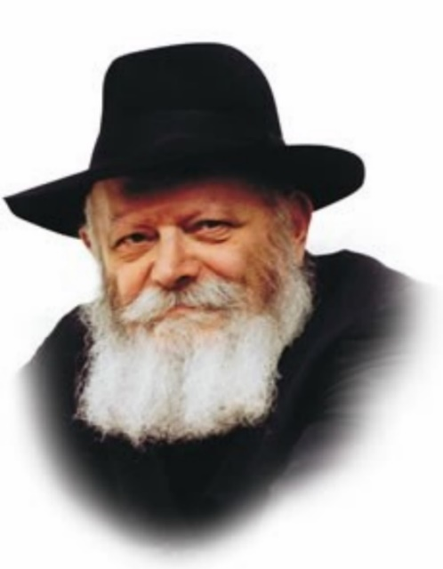

In this week's Torah portion, Lech Lecha, when Abraham was told by G-d that Isaac would be born, he already had Ishmael. Abraham said to G-d, "O, that Ishmael would live before You!"; Abraham would have been satisfied with just one son, if that son followed the ways of G-d.

G-d, however, explained that the Jewish people would be perpetuated through Isaac. G-d promised that eventually Abraham would have nachas (satisfaction), from Ishmael, but his true nachas would come from Isaac.

Ishmael's birth was a natural phenomenon, but Isaac's birth was a miracle. It was impossible for Abraham and Sara to have a child at such an advanced age. No one believed that such a miracle would occur. Yet, Isaac was born.

Another difference between Ishmael and Isaac was in their brit mila, the covenant that binds the Jew to G-d.

Ishmael was 13 years old when he was circumcised. At the age of 13 a person's intellect is already well established. He is able to make rational decisions based on his understanding, which is why he becomes obligated in mitzvot. At 13, Ishmael agreed to connect himself to G-d.

The circumcision of Isaac, by contrast, was performed when he was only 8 days old. One cannot obtain an infant's permission and it is precisely then that this eternal bond with G-d that can never be erased was affected.

Ishmael's upbringing was likewise natural. Ishmael grew up under the watchful eyes of his parents, who helped him acquire the proper understanding to enable him to connect to G-d. Their efforts were rewarded when he made the rational decision to undergo brit mila at the age of 13.

Judaism, however, cannot be based solely on the foundations of human understanding. Judaism as predicated on the intellectual capacities of a 13-year-old boy is unstable. If, as a more mature individual, that person were to encounter a new set of circumstances or find himself in an unfamiliar situation, there is no predicting how he will react. The basis of his Judaism -- his own understanding -- is deficient.

For this reason, G-d told Abraham that his true nachas would come from Isaac. Judaism is not based on the foundations of nature. The connection between the Jew and G-d transcends nature entirely; it is an eternal bond that endures forever. And the Judaism of a child whose connection with G-d is forged as an 8-day-old infant will be stable.

From this we derive an important lesson. Jewish education cannot be postponed until a child reaches the age of reason. From the moment of birth, one must inculcate the infant with Judaism that transcends the bounds of nature. A child thus educated will bring his parents true nachas.

*Reprinted from the Parshat Lech Lecha 5758/1998 edition of L’Chaim. Adapted from Likutei Sichot, Volume 1.*

*\*\*\*\*\*\*\*\*\*\*\*\*\*\*\*\*\*\*\*\*\*\*\*\*\*\*\*\*\*\*\*\*\*\*\*\*\*\*\*\*\*\*\*\*\*\*\*\*\*\*\*\*\*\*\*\*\*\*\*\*\*\*\*\*\*\**

*And He reckoned it to him as tzedakah (15:6)*

Rav Simcha Bunim of Pshischa z"l remarked: When Chazal say that it is irrelevant how much a person gives, provided that whatever he gives is for the sake of Heaven, they were not talking about a poor person. A poor person has to scrape together his pennies in order to give tzedakah, and whatever he gives is surely for the sake of Heaven.

Therefore, Chazal were obviously referring to a wealthy person. They are teaching us that even a wealthy person who gives a great deal of tzedakah must do so for the sake of Heaven. (Words of Wisdom, Words of Wit by Shmuel Hirtenfeld)

*Reprinted from the Lech Lecha 5783 email of R’ Yedidye Hirtenfeld’s whY I Matter parsha sheet of the Young Israel of Midwood in Brooklyn, NY.*

**Kanye West and the**

**Power of Words**

**By**[**Elliot Mathias**](https://aish.com/authors/48865537)

***Adidas and others who have gone out of their way to condemn hatred of Jews should be thanked. Let’s not stop there.***

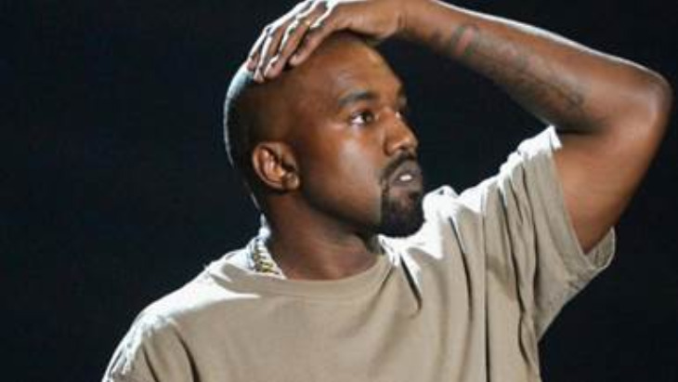

Kanye West was once the biggest hip-hop artist on the planet, with over 160 million records sold and 24 Grammy Awards. But West has been headlining the news recently for his blatant antisemitism. His string of antisemitic comments is not the first for the mega influential artist.

Back in November 2013, West stated in a radio interview, “Black people don't have the same level of connections as Jewish people... We ain't Jewish. We don't get family that got money like that."

West has taken his Jew-hatred to another level of vitriol. He suggested in an Instagram post that rapper Diddy is controlled by Jews. The next day, after being criticized for the post, he tweeted "I'm a bit sleepy tonight but when I wake up I'm going death con 3 On JEWISH PEOPLE. The funny thing is I actually can’t be Anti- Semitic because black people are actually Jew [sic] also ... You guys have toyed with me and tried to black ball anyone whoever opposes your agenda."

Several influential celebrities have been outspoken against West’s antisemitism, including David Schwimmer, Amy Schumer, Reese Witherspoon, Kim Kardashian (West’s ex-wife), Gwyneth Paltrow, Katie Couric, Kendall and Kylie Jenner, John Legend, Maria Shriver, and more. Each of these celebrities, and many others like them, should be congratulated and praised for speaking out against this hatred. Too often antisemitism takes a back seat to other acts of racism. Those who have gone out of their way to condemn hatred of Jews should be thanked.

Additionally, a number of companies have cut ties with West, including Vogue, Creative Artists Agency, Balenciaga, The Gap, and now Adidas. These decisions have real financial consequences, with Adidas acknowledging that its decision to sever ties with West would have a financial negative impact of at least $250 million in 2022. We should praise these companies that took real action to stand up against antisemitism.

**Aren’t They Just Words?**

Some may be wondering: Certainly, Kayne’s comments are deplorable, but aren’t we over-reacting? He hasn’t committed any acts of violence or caused damage to anyone personally. He said some hurtful words – is that such a big deal?

**“Words matter. A threat to Jewish people ended once in genocide. Your words hurt and incite violence.”**

The truth is that the words – especially those of influential people – can have a far-reaching impact. In response to West’s hatred, Jamie Lee Curtis powerfully posted, “Words matter. A threat to Jewish people ended once in genocide. Your words hurt and incite violence.”

Hateful words can give permission and encouragement to others to spread their hatred. Immediately after West’s comments, a group of Neo-Nazis placed banners on the 405 Highway in Los Angeles saying, “Kanye is right about the Jews.”

Economist David Yanagizawa-Drott found that approximately ten percent of the participation in the Rwandan genocide could be attributed to radio broadcasts, corresponding to an estimated 50,000 murders.

Hateful words can lead to devastating consequences.

**Every Person’s Words Make a Difference**

It’s not only influential people whose words can make an impact. Every person has the potential to use their words to hurt or uplift others.

Bullying has become a major problem in schools and online. Studies have shown that those who are bullied are at increased risk for mental health problems and long-term damage to self-esteem. Children and adolescents who are bullies themselves are at increased risk for drug use, academic problems, and violence to others later in life.

Words of encouragement from a parent, teacher, coach, colleague, or friend can instill confidence that lasts a lifetime. Giving a compliment to a co-worker positively impacts their emotional state that affects their interactions, creating a ripple effect of positivity.

**Time to Take Responsibility – Clean Speech**

We all fall prey to using our speech negatively. Whether it is gossip or unintended hurtful words, our words have less than ideal consequences.

Like the celebrities and companies who have stood up against antisemitism, we too need to take a stand against negative speech – in our own lives. It’s not easy, but by spending a little time each day focusing on our words, we can turn our hurtful speech into “clean speech”.

A great way to make this a part of your daily life is to join the “[Clean Speech Initiative](http://www.cleanspeech.com/nyc)”. It’s a 30-day campaign that will deliver a short daily video throughout the month of November, with practical ideas and tips to elevate our speech, all based on Jewish wisdom.

In New York City, 20 diverse organizations are joining together to implement the campaign. The campaign is also running in other cities around the world.

Now is your chance to take a stand. Improve how you speak and create a ripple effect of positivity that will influence your families, friends and community.

Visit [www.cleanspeech.com/nyc](http://www.cleanspeech.com/nyc) and join the “Keep it Clean” campaign today.

*Reprinted from this week’s website of aish.com*

*\*\*\*\*\*\*\*\*\*\*\*\*\*\*\*\*\*\*\*\*\*\*\*\*\*\*\*\*\*\*\*\*\*\*\*\*\*\*\*\*\*\*\*\*\*\*\*\*\*\*\*\*\*\*\*\*\*\*\*\*\*\*\*\*\*\**

*The bird of prey descended upon the carcasses, and Avram drove them away (15:11)*

In this vision, known as the Berit bein HaBetarim, Hashem showed Avram (Avraham) the four nations which would enslave the Jewish people. Each was represented by a different animal which Avram slaughtered (i.e., the carcasses).

The bird of prey represented mashiach (Why did Avram drive it away? Because, writes Abarbanel, Avram knew that a premature arrival of mashiach, while it would bring some salvation to the Jews, would prevent a complete redemption. This he wanted to prevent. (Yeshuot Meshicho)

*Reprinted from the Lech Lecha 5783 email of R’ Yedidye Hirtenfeld’s whY I Matter parsha sheet of the Young Israel of Midwood in Brooklyn, NY.*

**In an Australian Outback Mining Town, a Lone Jew Receives His Final Honors**

**By Mendel Super**

***Chabad rabbi and volunteers travel hundreds of miles for a Jew they never met***

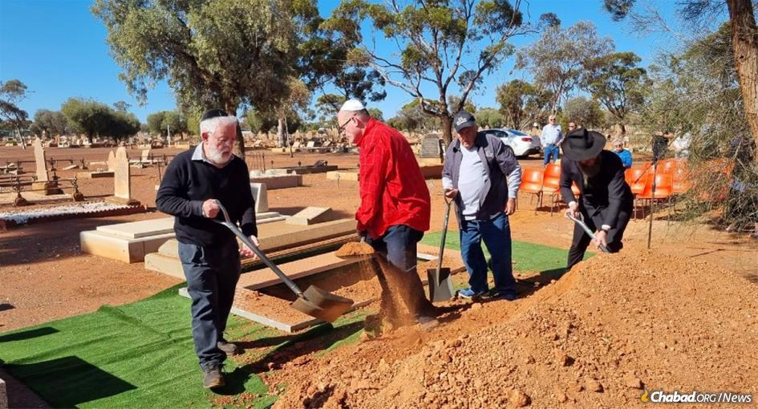

**Dr. Avron Moffson is laid to rest by members of Perth, Australia’s Jewish community, who traveled 14 hours for another Jew. From left, placing earth over the fresh grave: Dennis Davidoff, Marc Roth, David Ninio and Rabbi Shalom White.**

The dusty plains near Kalgoorlie, a forgotten mining town deep in the Australian interior, belie the rich Jewish history of Western Australia’s Goldfields region, once home to two synagogues during the peak of the gold-rush era in the early 20th century. While Kalgoorlie—some 370 miles from Perth, the nearest metropolitan area—may be remote, the handful of Jews there are not forsaken.

Just six people identified as Jewish in the most recent census, and [Chabad of Rural and Regional Australia](https://www.chabad.org/jewish-centers/252052/Caulfield-North/Synagogue/Chabad-of-Rural-and-Regional-Australia) (RARA) has kept in touch with them for decades, visiting to provide them with pastoral guidance and a Jewish connection, as recently as August.

When longtime Kalgoorlie physician Dr. Avron Moffson, 85, passed away on Oct. 10—the first day of [Sukkot](http://www.chabad.org/news)—the staff at a local funeral home was at a loss. How could they help him have a traditional [Jewish burial](https://www.chabad.org/library/article_cdo/aid/342062/jewish/Funeral-Burial.htm)? They posted on a local Facebook group asking if anyone knew what to do for a deceased Jew.

In Melbourne, 1,700 miles away, Avi Kassman, who used to live in Kalgoorlie, received a message from his sister-in-law, a Kalgoorlie resident, sharing the post.

Kassman knew Moffson from his Kalgoorlie days and was eager to help. “I met him about 10 years ago at his clinic with my son,” Kassman, who converted to Judaism, told[Chabad.org](http://chabad.org/news). “I was not Jewish yet, but on my way to becoming Jewish. He noticed our yarmulkes, and we got talking. He was a proud Jew.”

The not-yet converted Kassman later helped the doctor wrap *tefillin*and gave him a menorah for Chanukah, but soon moved to Perth to facilitate his conversion.

Moffson stayed in touch with Chabad of RARA and received periodic visits from their Roving Rabbis. Rabbi Shalom White, director of [Chabad-Lubavitch of Western Australia](https://www.chabad.org/jewish-centers/273337/Perth/Synagogue/Chabad-of-Western-Australia) in Perth sent him packages regularly.

Kassman called White to inform him of Moffson’s passing. At the same time, a Jewish businessman who visits Kalgoorlie had seen the post and notified the Perth [Chevra Kadisha](https://www.chabad.org/library/article_cdo/aid/4107711/jewish/The-Chevra-Kadisha.htm) (Jewish burial society). Mike Gomer, president of the Chevra Kadisha, also called White, and they liaised with the Kalgoorlie funeral home and made plans to travel to the outback. “Initially, the plan was that I would go myself, and conduct the *taharah*and the funeral,” explains White. However, being that preparing the deceased for burial is really a two-man job, Gomer decided he would accompany the rabbi on the long journey.

**Volunteers Set Out on 14-Hour Journey**

Joined by a small group of volunteers, White and Gomer headed out for the 14-hour round-trip journey on Thursday, Oct. 13. “We left Perth at 6 a.m. and returned at midnight,” says White. White brought along a pop-up *sukkah*, so the group could fulfill the mitzvah of eating in the [*sukkah*](https://www.chabad.org/library/article_cdo/aid/420823/jewish/How-to-Build-a-Sukkah.htm)even while on the road.

“It’s amazing that a group of Perth Jews gave an entire day just for a lone Jew who needed help,” says White. “I had always known about him and communicated with him, but the rest of the group had just heard of him for the first time after his passing .”

Kassman is similarly moved. “He was committed to living in remote areas and helping people,” Kassman says of Moffson. “He was well-loved by the community and helped many families with his services. He never forgot who he was as a Jew.” That community, in turn, made sure that this Jewish man was buried according to his sacred traditions.

Indeed, the outpouring of messages on Chabad of RARA’s Facebook page from local Kalgoorlie residents shows how beloved their doctor was, and how he made sure everyone knew he was a Jew.

“A fitting tribute to a dedicated doctor who gave much care to his patients. We will remember him,” wrote Donna Hendry.

“Bye mate. RIP. I’ll miss talking about cricket with you,” wrote another, one of dozens of such messages.

It had been a decade since the next most recent Jewish burial and at least a half a century since a rabbi had conducted a funeral there.

But by Divine design, Avraham ben Lazer Moffson was buried in Kalgoorlie’s Jewish section (marked by a small sign reading “Hebrew”), at rest in the deep red earth of the Goldfields.

*Reprinted from this week’s website of Chabad.Org*

******************************************************************

*And I will make your children as the dust of the earth* (13:16)

A Rabbi who intensely fought the missionaries in his town was visited by the bishop and asked, "Rabbi, why do you oppose us so strongly?"

The Rabbi replied, "When you convert someone to your religion, you sprinkle him with your 'ritual water.' Jews are compared to the dust of the earth. When one mixes water with earth, mud results. I cannot sit idly and see someone trying to make mud of my people." (L'Chayim)

*“When Avram heard that his kinsman [Lot] was taken captive, he armed his disciples . . .” (14:14)*

The Gemara (Nedarim 32a) teaches: Why was Avraham punished that his descendants were enslaved in Egypt for 210 years? Because he took Torah scholars to war! [Until here from the Gemara]

R’ Yitzchak Arieli z”l (1896-1974; Mashgiach of Yeshivat Merkaz Harav; author of Enayim La’mishpat) observes that Mashiach will be a descendant of Lot. [Mashiach will come from King David, who came from Ruth the Moabite, who was a descendant of Lot.] We see how Hashem brings the cure–the Final Redemption–from the very same source as the malady–the first exile, i.e., both are results of Avraham’s rescuing Lot. (Haggadah Shel Pesach Shirat Ha’geulah)

*Reprinted from the Lech Lecha 5783 email of R’ Yedidye Hirtenfeld’s whY I Matter parsha sheet of the Young Israel of Midwood in Brooklyn, NY.*